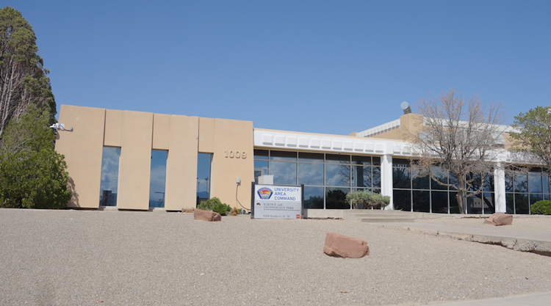University Area Command

Volume 1 / Issue 1



|  |
| --- |
|  |
| Newsletter Legend:  Commanders Corner  Message from The Chief  Summer Safety Travel Tips  How to reach 311  University Area Command Events Calendar |







6de53bc1-991d-df71-f192-86e827a54834 June, 2024

Commander’s Corner:

It is official! The University Area Command has been named the Albuquerque Police Department’s 7th Area Command. We also have our own website up and running for the University Area Command.

Officers in the University Area Command have been working very hard this year. We ended 2023 with a 12% increase in the crime category: Aggravated Assaults, and with a goal to see its reduction. I am happy to report as of June 3, 2024 we have seen a 24% reduction in Aggravated Assaults from this time last year which is a big win for the Area Command, our officers, and the community.

However, we are struggling with auto, commercial, and residential burglaries where we have seen significant increases. In response, we have officers on graveyard focused on patrolling neighborhoods and commercial areas which have been burglarized the most and have made some solid arrests.

On April 27, 2024 University Area Command officers responded to the 200 block of Harvard SE concerning a burglary. Officers arrested a woman for Commercial Burglary and booked her into the Metropolitan Detention Center (MDC). She has an extensive criminal history with at least 18 arrests I could count in her arrest record.

On May 1, 2024 (four days later) the same woman was released from MDC and burglarized a business in the Valley Area Command the same day and was arrested on that charge as well.

This is a trend we are seeing in the area command and with all that in mind we need your help in combating the rash of burglaries in the city. Here are a few things you can do:

1. Install surveillance equipment for your home – this can be something as simple as a Ring camera that can help you and even sometimes your neighbor prevent crime and sometimes solve them.

2. Report all burglaries that occur – if you noticed someone opened your car door overnight but maybe only took something small so you don’t think you need to report it, don’t! Please report it, go online, and please let us know what’s happening in your neighborhood so we can be proactive in addressing crime.

3. Lastly, take all your belongings out of your car at the end of the day ESPECIALLY FIREARMS when they are parked. There is no better way to protect your stuff than not making it a target in the first place.

If you or your neighbors see suspicious activity call (505) 242-COPS and report it. With the combined help of the community I am confident we can reduce burglaries by the end of the year.

As always, thank you for your continued support. Have a great summer!

Commander Ray Del Greco

Message from Chief Medina:

Hello everyone! I’d like to start off by sharing more on the good news that The Albuquerque Police Department has met all requirements in the Court-Approved Settlement Agreement with the U.S. Department of Justice, marking the biggest milestone since the reform process started in January 2015.

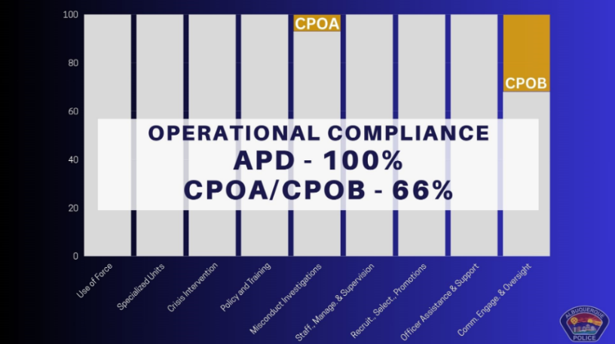I’d like to thank the officers who stayed with the Albuquerque Police Department and fought through these changes to make sure that we improved the services that we deliver to the citizens of the city of Albuquerque. Reform shall never end for any police department. We should always be evolving to see how we could become a better police department, more in tune with the community, and always changing to meet the needs of an ever-changing society.



Some terms of the settlement agreement that are outside the control of APD, dealing with civilian oversight, have not yet been met. But the monitor’s report means APD can move toward self-monitoring with all of its remaining sections that have not already been dismissed by the Court.

Looking ahead, we are kicking off a new program just in time for the summer months bringing Crime Prevention Pop-Ups to neighborhoods and parks.

APD is partnering with Albuquerque Metro Crime Stoppers in an effort to make crime prevention information accessible, build stronger community connections, and create an opportunity for community members to share their concerns; these events will be taking place throughout the summer.

We will have booths showcasing crime prevention, neighborhood watch, auto theft VIN etching and free wheel lock distribution, as well as more information on Crime Stoppers.

Please visit APD’s website, www.cabq.gov/police, for more information on the upcoming dates.

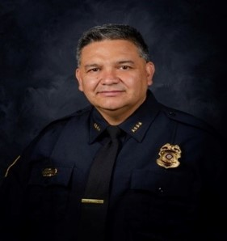

**Chief Harold Medina**

Summer Travel Safety Tips:

**Securing Your Residence and Preparing for Travel – Reduce Criminal Opportunity**

There are traditional times each year that many of us choose to travel to see family and friends as well as enjoy a fun vacation away from home. Here are a few tips for everyone to keep in mind when preparing for your summer trips.

* Ask a trusted neighbor to watch your residence and report suspicious activity.
* Install automatic timers on lights, TV's and radios to give the impression someone is home.
* Don't forget to have mail and newspaper delivery stopped. If you have a rollout trash dumpster, have a neighbor place it in the street on pick up day and return it that evening. Also, ask them to park a vehicle in the driveway whenever possible.
* Be extra cautious about locking all doors and windows.
* Make sure trees and shrubs are trimmed to allow for good natural surveillance of your property.
* Make arrangements to have exterior lights on each night.
* Each entrance should have solid core or metal doors and deadbolt locks.
* All primary window locks should be operational and secondary locks should be installed.
* Let neighbors, family and friends know when you plan to return from a trip.

## **Travel and Hotel/Motel Safety**

* Always be aware of your surroundings and trust your instincts.
* Lock all personal items in the trunk or away from view – roll up windows, lock doors and take your keys.
* Park in well-lit areas with a lot of activity. Park as close to an entrance as possible.
* Always verify who's at your door. If you are not expecting a visitor, call the front desk if the person claims to be with the facility and do not open the door to strangers or solicitors.
* Turn on the TV or radio when you are away from the room and leave a light on.
* Request a room closest to the main office – avoid end units. Higher floors are preferred.
* Identify emergency exits and discuss hotel/motel safety and security with family members.
* Keep valuables in the hotel/motel safe or leave them at home.
* Carry a minimum amount of luggage and never leave them unattended.
* Carry only those personal items necessary for a particular trip. Use traveler's checks or credit cards whenever possible. Leave local credit cards at home.
* Avoid carrying a purse whenever possible. Place money and credit cards in a front or jacket pocket. If you must carry a purse, carry it close to your body with flap facing inward and place strap around your shoulder (never wrap it around your body or neck).
* Don't display your room key or leave them in places they can be easily stolen.

**APD Crime Prevention – (505) 768-2006**

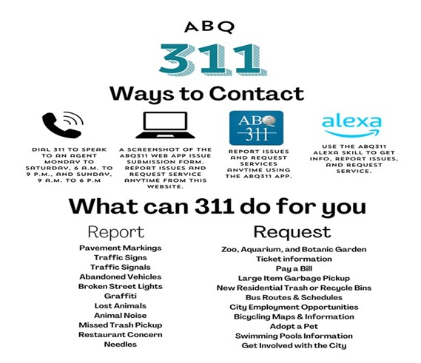

# SWIM PASSES

# Summer 2024 Ditch Passes Available Here:

**“Swim and Play Pass Program" encourages youth to avoid Albuquerque's deadly ditches.**

Children are out of school for the summer, which means they will be looking for things to do during the summer months, often that means playing in area ditches and arroyos.

Ditch and arroyo safety will and should be a top concern for parents and public safety departments as June will begin the summer monsoon season.

The Swim and Play Pass Program is organized by the Ditch and Water Safety Task Force, a multi-agency task force dedicated to educating residents in Albuquerque and the surrounding areas about the dangers of ditches and arroyos.

The program is specifically designed to encourage children to play safe by swimming in community pools or skating at city parks, rather than in ditches and arroyos, during the summer months.

Summer swim passes are good at all City of Albuquerque County pools and are good until September 2, 2024. Recipients must be 17 and younger to use a free pool pass.

The Dangers of Arrows and ditches:

Although arroyos and ditches can appear harmless, it's important to remember that a flash flood, New Mexico's number one natural disaster, can occur at any moment. Drowning victims have ranged in age from 2 to 87 years old. You can find more “Ditch & Arroyo information” on the City of Albuquerque website.

<https://ditchtheditches.com/swim-passes/>

TASK FORCE INFORMATION:

For more information on Ditch and water safety please contact the Ditch and Water Safety Task Force:

* Website: Ditches are Deadly
* Telephone: 505-764-4444, ext. 241

**Stay safe this summer by swimming in our community pools. It's easy!**

## **Go to a pickup location listed below for a free pass OR take the pledge at** [**https://ditchtheditches.com/swim-passes/**](https://ditchtheditches.com/swim-passes/)

(All requirements and steps needed for the pledge are listed on the website)

**Swim passes are good at all City of Albuquerque and Bernalillo County Pools.**

## ...

## PICKUP LOCATIONS

  

Albuquerque Fire Rescue APD Area Commands Bernalillo County Fire

# ☺ SAfty TIPS to Beat The HEat THis summer ☺

**Its official start of summer!!! >>>here are a few safety tips to remember:**

⇒**Hydrate** – When temperatures get warmer stay hydrated throughout the day. Know the signs and symptoms of heat-related illnesses.

⇒ **Bike Safety** – Always ride with a properly fitted bike helmet.

⇒ **Avoid Hot Cars** – It is critical to never leave a child or pet in a vehicle for any reason, no matter what the temperature or length of time.

⇒ **Apply Sunscreen** – Avoid the hottest part of the day from 10 A.M. -5 P.M.

⇒ **Pool & Hot Tub Safety** –Have drains covered and fence enclosures. Always wear a life vest and supervise children at all times.

⇒ **CPR Classes** – https://www.cabq.gov/fire/safety-information/hands-only-cpr

⇒ **City of Albuquerque Aquatics Centers** – For centers, programs & classes click the link for further information. https://www.cabq.gov/parksandrecreation/recreation/swimming

|  |
| --- |
|  |

### 

|  |
| --- |
|  |